
Contact Person: Rev Jonny Blair
jonny@waltonparish.org.uk
Tel: 07466 401 614
Application Form

The details you provide on this application form will be used solely for the purpose of progressing your application for the role given in Section 1 below. Your application form and any related notes will be kept with your employment file if you are successful, otherwise they will be destroyed securely no more than 6 months after the interview process is completed.

- Job Details – Autumn 2025
Please send completed applications, along with a completed confidential Self-Declaration form to Rev Jonny Blair by email at jonny@waltonparish.org.uk.

Applications: The position will remain available until filled. Shortlisting will be done on receipt of applications and interviews will be held by arrangement.

Position Applying for:
Worship Leader

- Personal details

Title: |  | Surname/Family name:
Forename(s):
Address:
Post code:
Contact Phone No:
Contact Email:

I declare that I am legally entitled to live and work in the UK YES/NO

I require a work permit to work in the UK YES/NO

Are there any dates where you are unavailable for interview or to take up the role? YES/NO
If YES, please provide details:

- Education history and other training courses including qualifications

Name of establishment | From | To | Subject studied / Qualifications gained
Secondary Education
Further Education
Training relevant to this application (if any)

- Employment history to date

Starting with your current or most recent employer, please tell us about your past and current employment / voluntary work in the table below. Please account for any gaps in your employment history.
Employers Name & address | Employed from (date) | Employed to  (date) | Job Title and brief description of responsibilities and duties | Reason for leaving
- Your application
Looking at the role description, please tell us how your previous experience makes you a good match for the role. You can draw on examples from other work, volunteering or other life experiences (approx. 300 words).

Please say something about your motivation for applying for this role and explain how this role fits in your career path.

- Other information
Are you familiar with the beliefs and practices of the Church of England? YES/NO

Please indicate how you currently live out your faith:

Would you require any adjustments to assist you in preparing for, or attending, an interview?
YES/NO

If YES, please provide details:

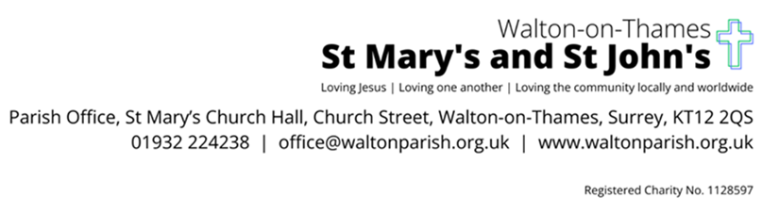
References

Reference 1 - Your current Church leader
Title Forename Surname
Job Title
Phone (please include area / country code)
Contact email
Address

Reference 2 – Employer (current or most recent). If the same as Reference1, please ask another leader in the Church, Churchwarden or Trustee
Title Forename Surname
Job Title
Phone (please include area / country code)
Contact email
Address
Dates employed from to

Reference 3 - Personal reference
Please give details of a non-relative who has known you for a minimum of 2 years.
Title Forename Surname
Relationship to you (colleague / neighbour etc)
Phone (please include area / country code)
Contact email
Address
How long has this person known you?

DECLARATION

I declare that this application form has been completed by me. All the information on this application form is true to the best of my knowledge and belief. I understand that my application may be rejected and/or I may be dismissed if I have given false information or withheld relevant details. I understand that it is my responsibility to update Walton Parish in the event that any of this information changes.

Signed:

Date:

Equal Opportunities Monitoring Form
The Parish of Walton-on-Thames is committed to diversity amongst its staff. To assist us implement and monitor this appropriately, applicants are asked to complete the information below. Completing this form is optional; you may leave any or all of these questions blank.
This form will be retained securely in the Church Office and separated from your application form. It will not be made available to the short-listing panel.
Role applied for:
Application Date (mm/yy):
Where did you find out about this role?
1. Ethnicity
Please highlight ONE option that most closely represents your cultural background.

A WHITE
British
Irish
Other (Please specify)
B MIXED
White and Black Caribbean
White and Black African
Other White and Asian
Any other mixed Background (Please specify)
C ASIAN or ASIAN BRITISH
Indian
Bangladeshi
Pakistani
Any other Asian Background (Please Specify)
D BLACK OR BLACK BRITISH
African
Caribbean
Any other Black background (Please specify)
E CHINESE
Chinese
Any other Chinese Background (Please specify)
F OTHER (Please specify)
G PREFER NOT TO STATE

2. Gender Identity
What best describes your gender? Male / Female / Prefer not to say / Prefer to self-describe: _________
Is your gender identity the same as the sex you were assigned at birth? Yes / No / Prefer not to say
3. Age category 16-19 / 20-29 / 30-39 / 40-49 / 50-59 / 60+ / Prefer not to say
4. Disability
The Disability Discrimination Act 1995 outlines the definition of a disability as “A physical or mental impairment, which has a substantial and long-term adverse effect on a person’s ability to carry out normal day-to-day activities”.
Based on this description, do you consider yourself to be disabled? Yes / No / Prefer not to say
5. Religious Belief Please indicate your religious beliefs:
No religion Christian (inc. CofE, Catholic, Protestant & all other Christian denominations)
Buddhist Hindu
Jewish Muslim
Sikh Any other religion (please give details): ______________________________
Prefer not to say
Thank you for completing this form. Please return it with your application.

